**Diet Manager Version 1.0**

Project Design Document

Team Cake

Tenzin Dhondup <txd5857@rit.edu>

Chad Cummings <cbc6525@rit.edu>

Zhimin Lin <zxl1987@rit.edu>

Chandler Sofia Michel <csm4025@rit.edu>

Daniel Cox <drc8599@rit.edu>

**Project Summary**

Diet Manager is a program that helps users monitor their diet. Each time a user eats, they can enter in a food item or multiple food items that make up a recipe. For each food item they enter, they must provide the name and nutritional information (i.e. calories, fat, etc.). For each recipe the user enters, they must provide the name and the basic food items that make up the recipe. After the user enters in a food item or recipe the first time, it is added to the food collection and they may select it at another time, without having to add it again.  
  
Diet Manager shows users an overall look at the user’s daily dietary information in terms of calories, fat, carbs, and protein. Diet Manager also tracks the user’s weight by allowing the user to periodically input their weight. Additionally, users can set a daily calorie limit and Diet Manager will inform the user if they are under or over their daily limit.

**Design Overview**

The Diet Manager design incorporates the Composite design pattern and the Model-View-Controller (MVC) architectural pattern. A preliminary design did not incorporate the MVC architectural pattern, but it was later added in order to produce a more extensible application. The Composite pattern is used in order to create a cohesive relationship between the Recipe and BasicFood objects. This section will be updated as we continue to move through the design process.

**Subsystem Structure**

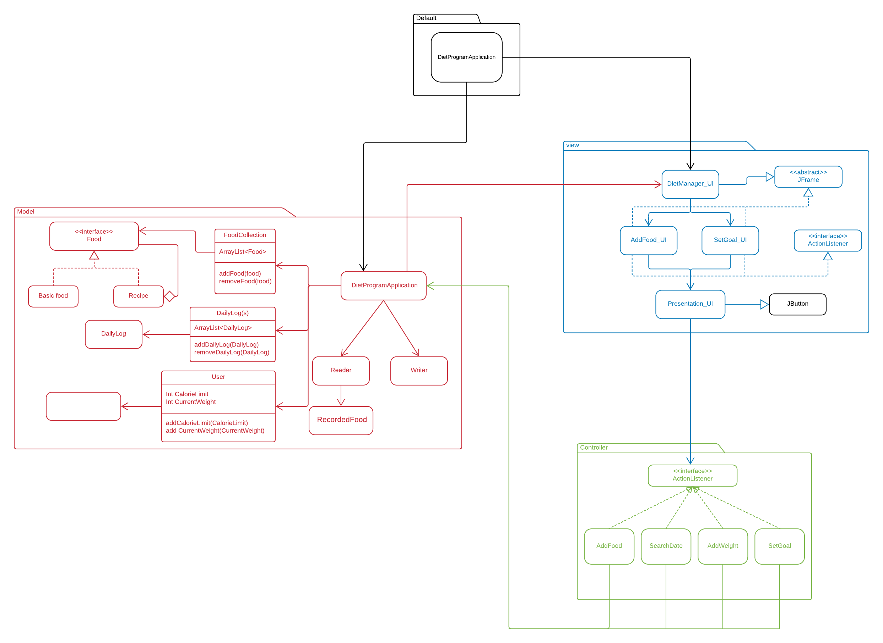

**Default Subsystem**

|  |  |
| --- | --- |
| **Class** DietManagerProgram | |
| **Responsibilities** | Create the model object(s).  Create the graphic user interface.  Display the GUI for user to used. |
| **Collaborators**  **(uses)** | **model.DietProgramApplication -** the primary model class |

* 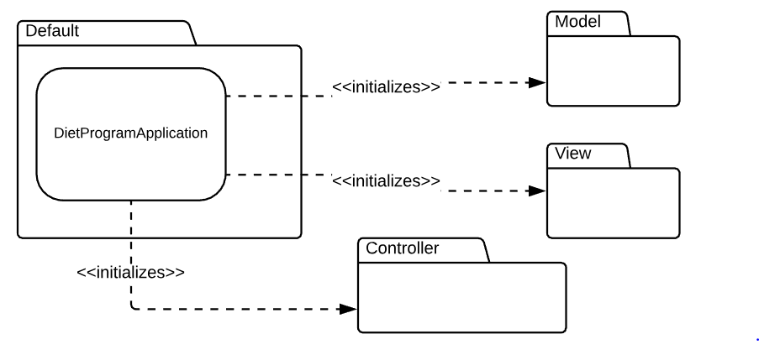

**Model Subsystem**

Still needs to implement

|  |  |
| --- | --- |
| **Class** DietProgramApplication | |
| **Responsibilities** | Notify observers (UI) of changes to the |
| **Collaborators**  **(uses)** |  |

|  |  |
| --- | --- |
| **Class** Writer | |
| **Responsibilities** | Allow csv entries to be written to all CSV files ( foods.csv, log.csv) |
| **Collaborators**  **(uses)** | **java.io** - to use the PrintWriter and File classes  **java.util** - to use Calendar class |

|  |  |
| --- | --- |
| **Class** Reader | |
| **Responsibilities** | Allow csv entries to be read from all the CSV files (basicfood.csv, foods.csv, log.csv) |
| **Collaborators**  **(uses)** | **java.io** - to use the PrintWriter and File classes  **java.util** - to use Calendar class |

Still needs to implement.

|  |  |
| --- | --- |
| **Class** User | |
| **Responsibilities** | Stores the user’s current weight and desired caloric intake.  Update the user’s current weight and desired caloric intake. |
| **Collaborators**  **(uses)** | **java.io** - to use the PrintWriter and File classes  **java.util** - to use Calendar class |

|  |  |
| --- | --- |
| **Class** DailyLog | |
| **Responsibilities** | Creates a Daily Log object / entry for the Writer Class.  Takes in values and stores user’s recorded weight.  Takes in values and stores user’s desired caloric limit. |
| **Collaborators**  **(uses)** | **Model.RecordWeight**  **Model.RecordFood** |

|  |  |
| --- | --- |
| **Class** Weight | |
| **Responsibilities** | Takes in values and stores user’s recorded weight and date.  Stores it in an object, along with the selected date. |
| **Collaborators**  **(uses)** | **java.util.Date** |

|  |  |
| --- | --- |
| **Class** ConsumedFood | |
| **Responsibilities** | Takes in values and stores user’s “consumed” food and date.  Stores it in an object, along with the selected date. |
| **Collaborators**  **(uses)** | **java.util.Date** |

|  |  |
| --- | --- |
| **Class** CaloricIntakeLimit | |
| **Responsibilities** | Takes in values and stores user’s “caloricintake” and date.  Stores it in an object, along with the selected date. |
| **Collaborators**  **(uses)** | **java.util.Date** |

|  |  |
| --- | --- |
| **Class** Food (interface) | |
| **Responsibilities** | Provide a generic interface to all food items ( Recipe and Basic Food).  getNutrDiet() - Method that returns the nutritional information.  getName() - Method that returns the name of the food or recipe  *Composite Pattern* |

|  |  |
| --- | --- |
| **Class** BasicFood | |
| **Responsibilities** | Following Attributes are the Name, Calories (*number of calories in one serving of that food*), fat, carb, and protein ( *number of grams in one serving of that food each*).  getNutrDiet() - Method that returns an array of the values of all the attributes listed above. Ands add them to a NutrDiet Array.  getName() - Method that returns the name of the food  *Leaf in the Composite Pattern* |
| **Collaborators**  **(**implements**)** | **Model.Food** |

|  |  |
| --- | --- |
| **Class** Recipe | |
| **Responsibilities** | A collection of basic food and sub-recipes. Following Attributes are the Name (*of the Recipe*), the name of either the Basic Food or Subrecipe(*that makes up Recipe*), number of servings (*of that Basic Food or Subrecipe that was listed*). In the Recipe composite, it can have multiple Basic Food/Subrecipe depending on the composition of the Recipe.  getNutrDiet() - Method that returns an array of the values of all the attributes listed above. Ands add them to a NutrDiet Array.  getName() - Method that returns the name of the recipe |
| **Collaborators**  **(**implements**)** | **Model.Food** |

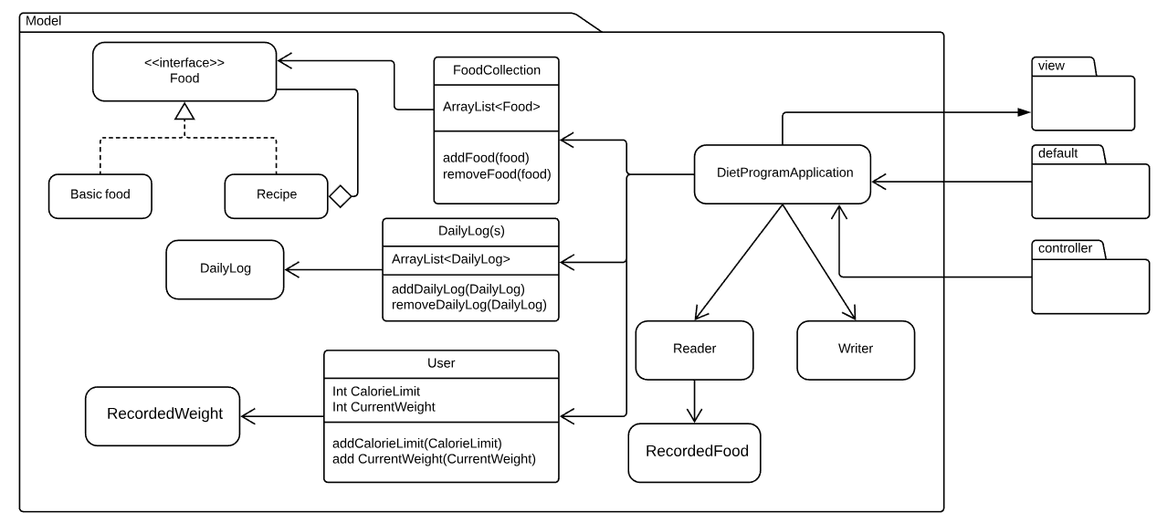

**View Subsystem**

|  |  |
| --- | --- |
| **Class** Current Command Line Interface. | |
| **Responsibilities** | Is the User Interface of the DietManager in terms of interacting with the features such as adding food, updating weight/desired caloric limit. |
| **Collaborators**  **(uses)** | **Controller.** |

|  |  |
| --- | --- |
| **Class** DietManager_UI | |
| **Responsibilities** | Is the User Interface of the DietManager in terms of interacting with the features such as adding food, updating weight/desired caloric limit. |
| **Collaborators**  **(uses)** | **All the classes listed below.**  **As well as all classes will use javax for the visual elements.**  **implements - ava.awt.event.ActionListener** |

|  |  |
| --- | --- |
| **Class** AddFood_UI | |
| **Responsibilities** | Contains all the required UI components that makes up the screen of which users interact with to add food ( basic food / recipe ) to the food collection or adding the consumed food to the daily logs |
| **Collaborators**  **(uses)** | **Controller.AddFood** |

|  |  |
| --- | --- |
| **Class** SetGoal_UI | |
| **Responsibilities** | Contains all the required UI components that makes up the screen for which the user can not only enter in their desired caloric count and their weight but the interface will also display the change of values over time. |
| **Collaborators**  **(uses)** | **Controller. setGoal / .AddWeight** |

|  |  |
| --- | --- |
| **Class** Presentation_UI | |
| **Responsibilities** | Contains all the required UI components that makes up the screen that will display users dietary nutritional information. |
| **Collaborators**  **(uses)** |  |

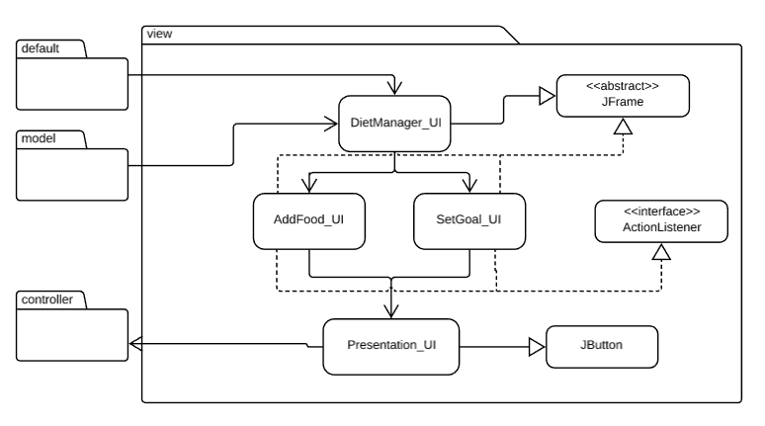

**Controller Subsystem**

|  |  |
| --- | --- |
| **Class** AddFood | |
| **Responsibilities** | Creates a Food object which will basically add the object to the Daily Log and Food Collection. |
| **Collaborators**  **(uses)** | **Model.Food**  **Model.Writer**  **Model.DietManagerApp** |

Still need to work on.

|  |  |
| --- | --- |
| **Class** SearchDate | |
| **Responsibilities** | Searches through the Daily Log using the Date attribute, which filter the results correlated to that selected date |
| **Collaborators**  **(uses)** | **Model.DietManagerApp** |

|  |  |
| --- | --- |
| **Class** AddWeight | |
| **Responsibilities** | Updates the user’s current Weight of that day. |
| **Collaborators**  **(uses)** | **Model.DietManagerApp**  **Model.User** |

|  |  |
| --- | --- |
| **Class** SetGoal | |
| **Responsibilities** | Updates the user’s current Weight of that day. / Caloric Limit |
| **Collaborators**  **(uses)** | **Model.DietManagerApp**  **Model.User** |

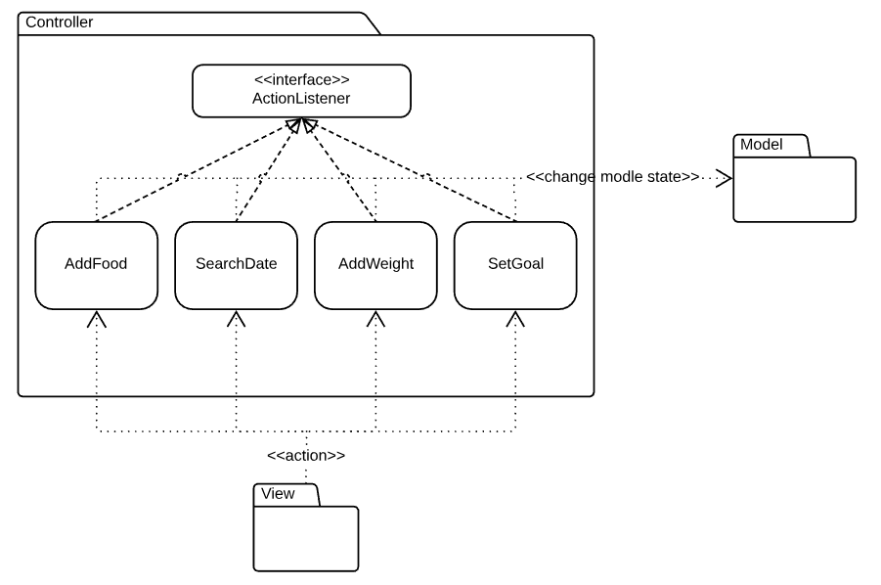

**Sequence Diagrams**

**Sequence description 1**:

Adding a meal into the daily log

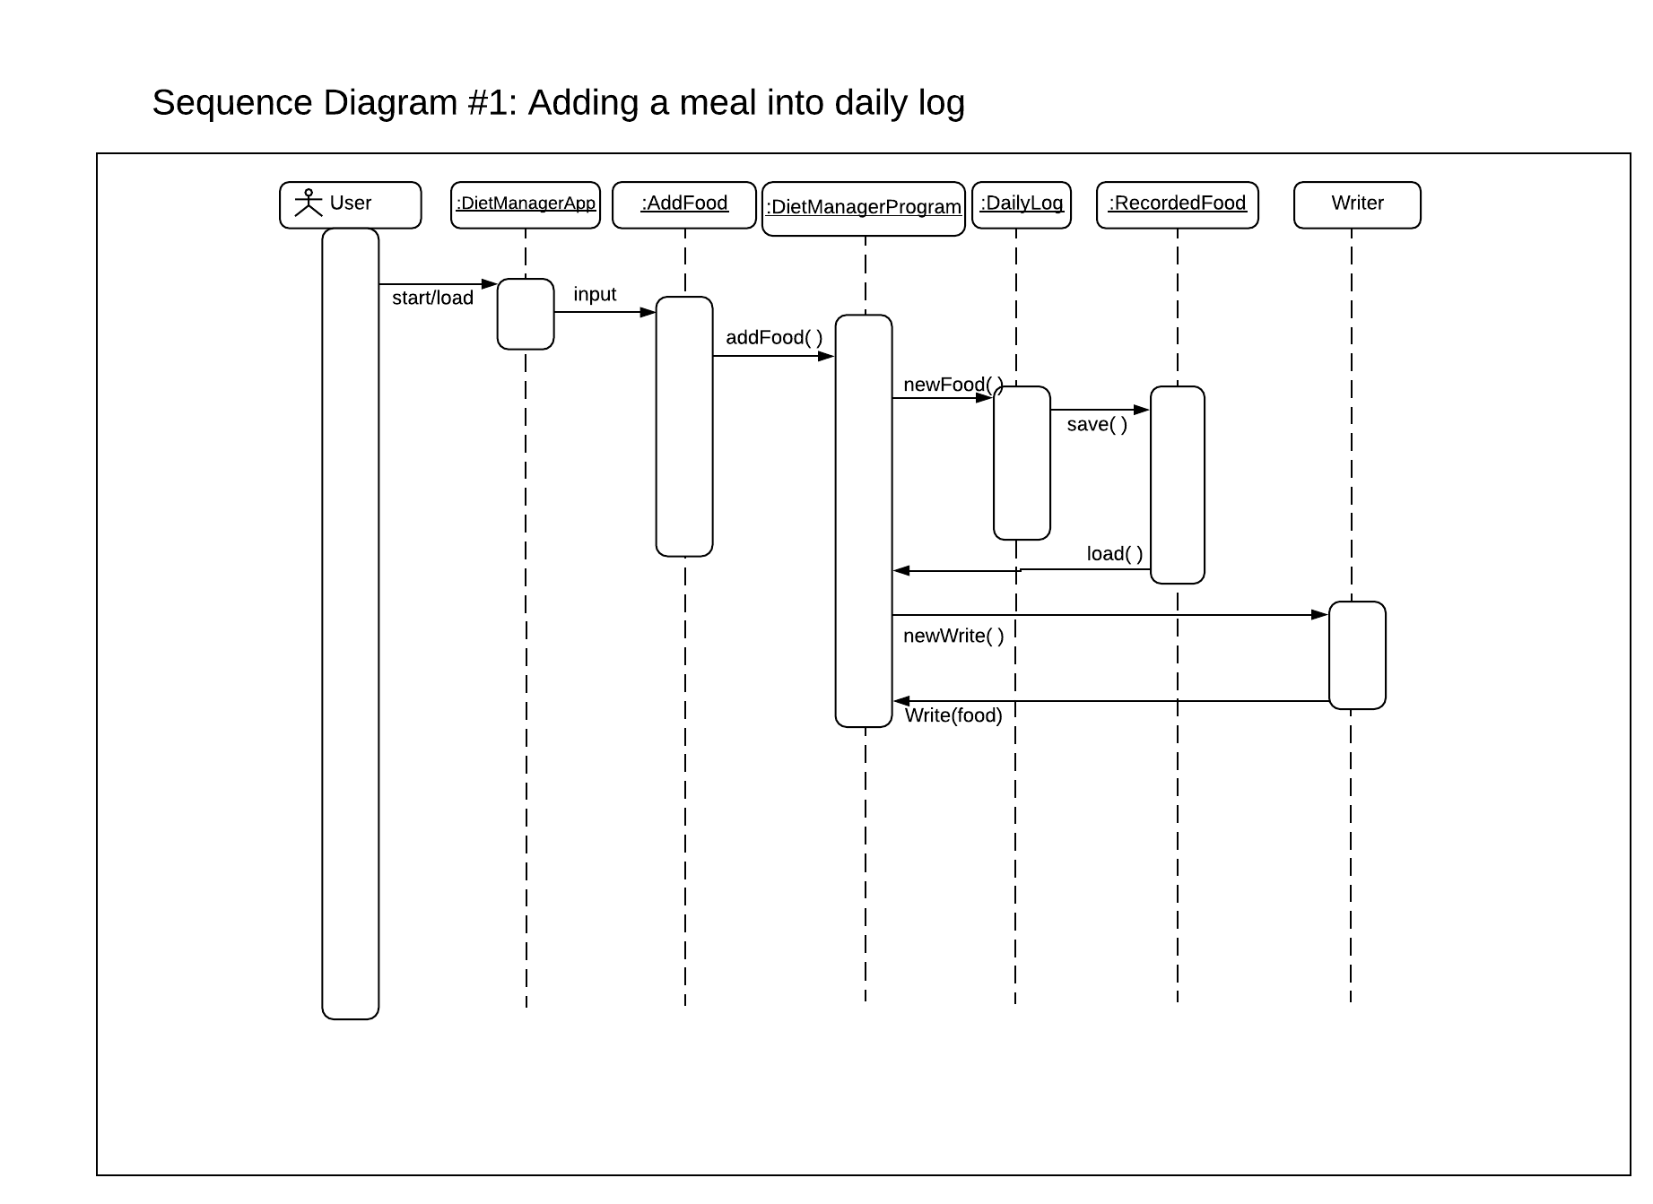

**Sequence description 2:**

Getting the total calories from the recipe and its basic foods.

Pattern Usage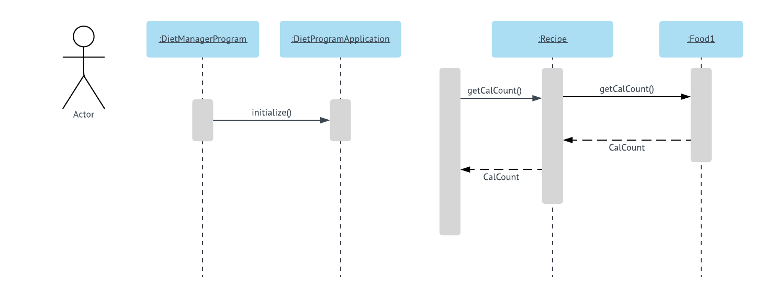

**Pattern #1 Composite**

The Composite pattern is used in order to create a cohesive relationship between the Recipe and BasicFood objects.

|  |  |
| --- | --- |
| **Composite Pattern** | |
| **Composite(s)** | Recipe |
| **Leaf(s)** | BasicFood |
| **Component** | Food |

**Pattern #2 MVC**

Use the Model View Controller pattern to organize the application.

Example: User wants to add a new basic food.

View: 1. Received “add a new basic food” request from user.

2. Send a request to Controller about the user adding a new basic food.

Controller:1. Received “user adding a new basic food” request from View

2. Send a request to Model about adding a new basic food for that user.

Model: 1. Received “add a new basic food for the user” from Controller.

2. Adding the new basic food for that user.

3. Send notice to Controller about “New food added”

Controller:1.Received notice from Model, start collect new set of data.

2. Send notice to View about “new data collected”.

View: 1. Receive notice from Controller about “new data collected”.

2. Display the new data to the User.

|  |  |
| --- | --- |
| **MVC Pattern** | |
| **Model** | DietProgramApplication, Writer, Reader, User, DailyLog, RecordedWeight, RecordedFood, BasicFood, Recipe |
| **Views** | DietManager_UI, AddFood, SetGoal, Presentation |
| **Controllers** | EventListener, SetGoal, AddFood, SearchDate, AddWeight |